Practical - 4
Practical Title: JavaScript DOM Manipulation, Event Handling, and UI Interactivity

Problem Definition: Add dynamic UI components such as collapsible FAQ, modal popup, image/content slider, notification banner, hamburger menu, and light/dark

theme switcher using JavaScript.

Theory

- How are DOM elements selected and modified?
Answer: DOM elements are selected using methods like getElementById(), querySelector(), and querySelectorAll(). They can be modified using properties such as textContent, innerHTML, style, and classList..

- Are event listeners attached correctly?
Answer: Yes. Event listeners are attached using addEventListener(), which allows JavaScript to respond to actions such as clicks, checkbox changes, and button presses.

Is localStorage used for remembering theme choice?
Answer: Yes. localStorage can store the user's selected light/dark theme, so the same theme can be automatically applied when the user visits the website again.

Does interactivity improve usability without breaking accessibility?

Answer: Yes. Features such as theme switching, menus, modals, and password visibility improve usability when they are implemented with clear labels, keyboard support, and appropriate HTML elements.

Implementation :
- Collapsible FAQ – JavaScript shows/hides answers when questions are clicked.
- Modal Popup – JavaScript opens and closes a popup on button click.
- Image/Content Slider – JavaScript changes images/content using Next/Previous buttons.
- Notification Banner – JavaScript displays and hides important notifications.
- Hamburger Menu – JavaScript toggles the navigation menu on click.
- Light/Dark Theme – JavaScript switches between light and dark modes and can save the choice using localStorage.
- DOM Manipulation – JavaScript selects and modifies HTML elements dynamically.
- Event Listeners – addEventListener() handles user interactions.

Evidence of Work (Screenshots)
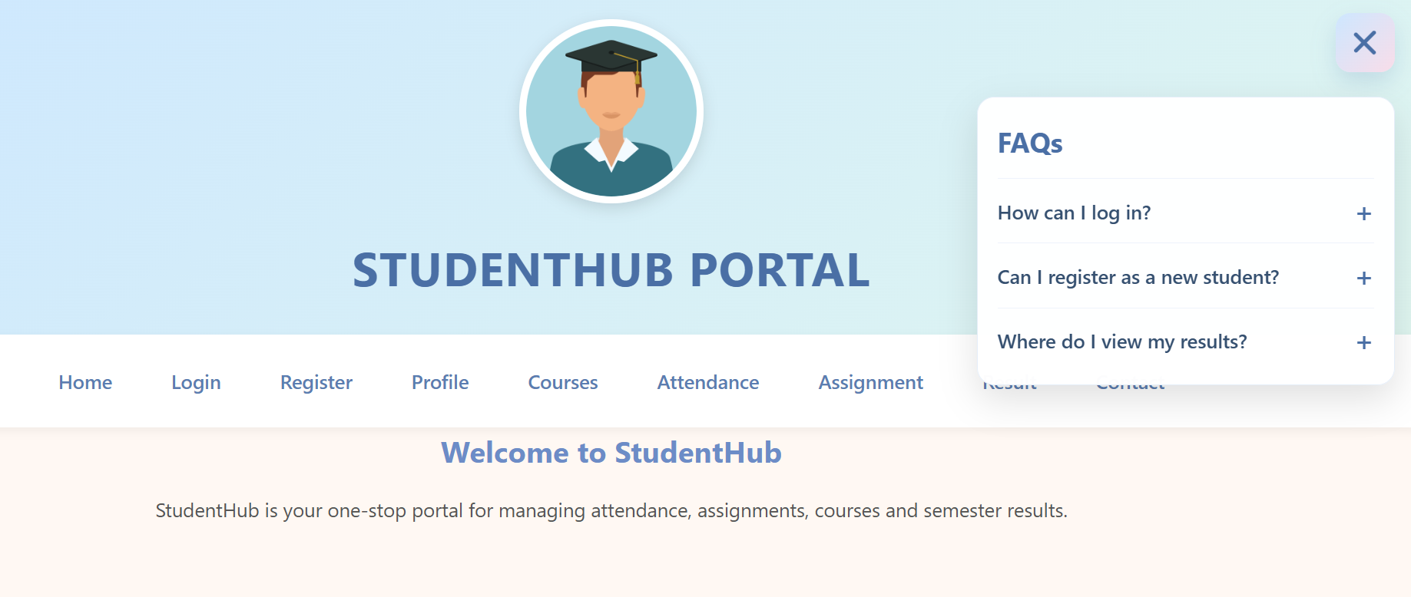
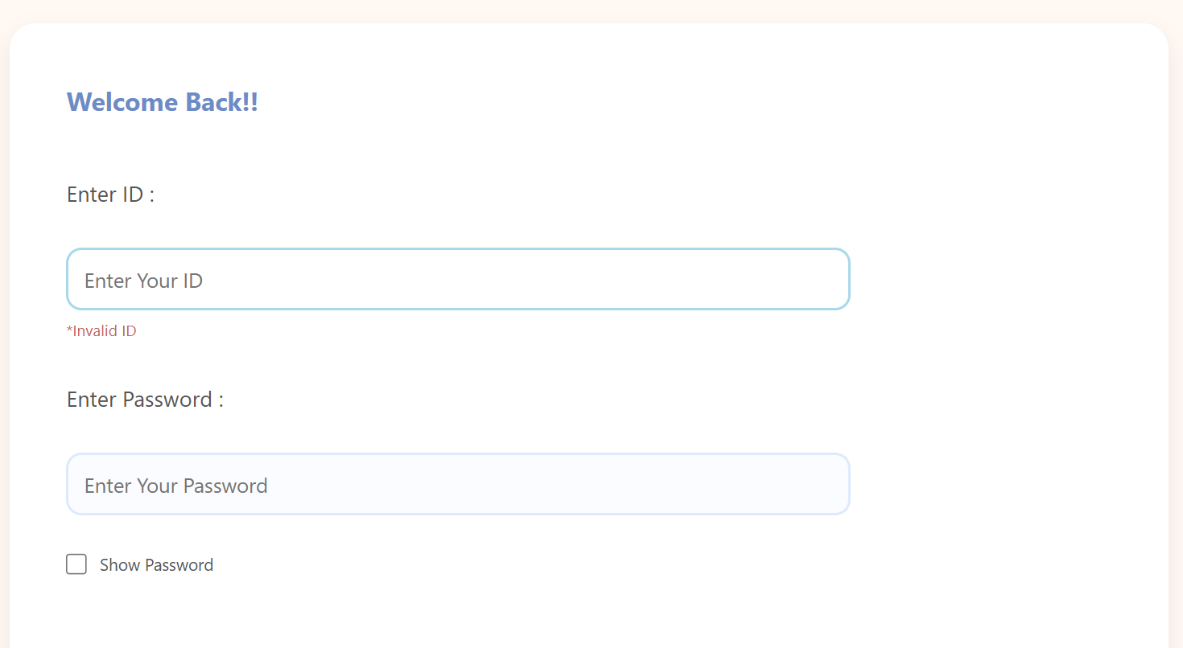
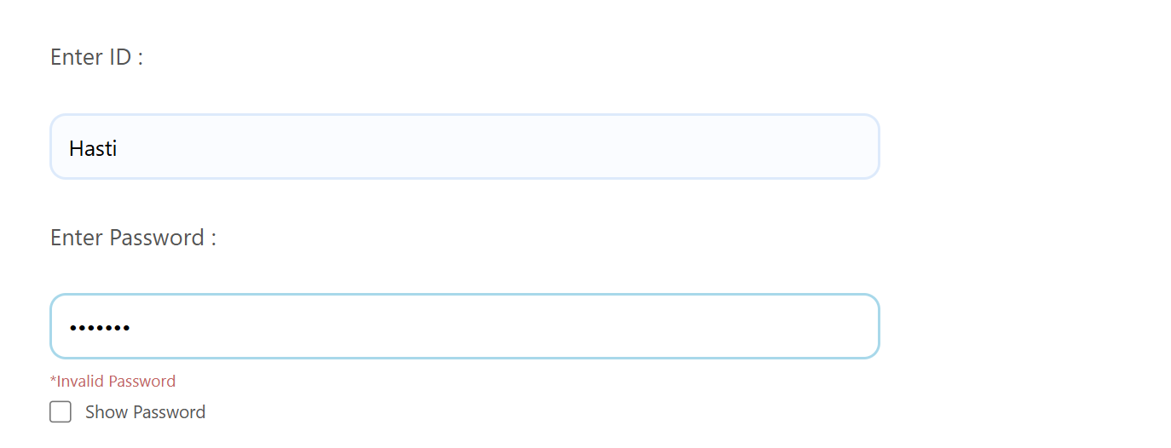
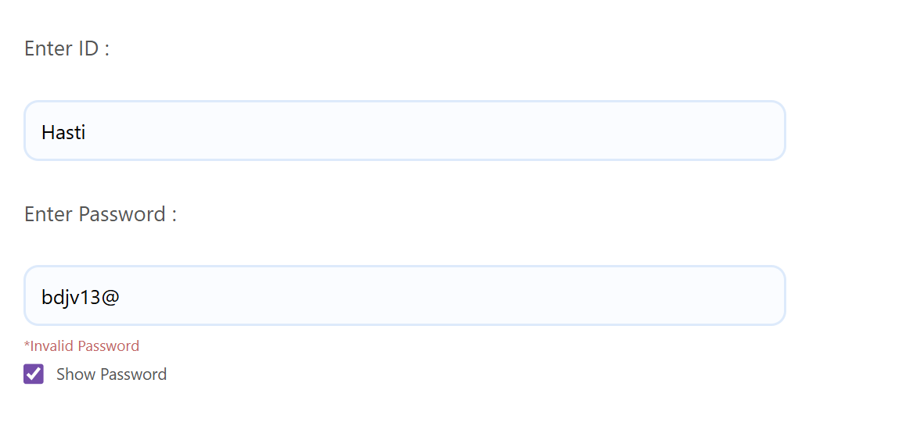
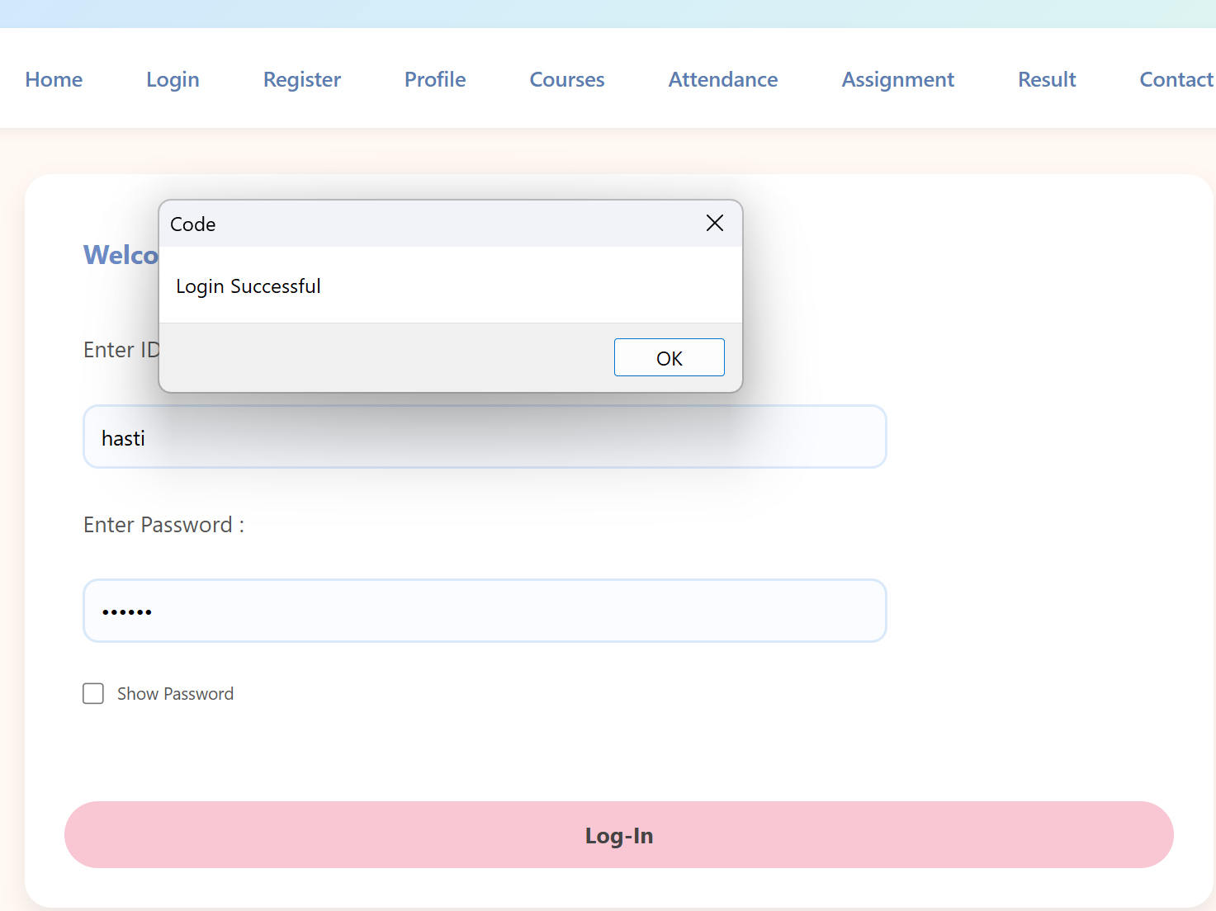

GitHub Repository Link:

https://github.com/kansagarahasti24/WDF

Challenges Faced:
• Understanding JavaScript DOM manipulation.
• Handling multiple event listeners correctly.
• Implementing responsive hamburger menu and slider.
• Managing light/dark theme using localStorage.
• Maintaining accessibility and proper UI behavior.

Learning Outcomes:
• Learned to create dynamic and interactive web components.
• Improved understanding of JavaScript events and DOM.
• Learned to use localStorage for saving user preferences.
• Gained experience in responsive and user-friendly UI design.
• Improved debugging and problem-solving skills.

Faculty Remarks: (Keep this blank for faculty)

